**Oracle SQL Statements with Errors and Poor Formatting**

1) Identify errors in the following Oracle SQL statement and label errors with error type (syntax, redundancy, or semantic). To simplify your work, the statement has only one type of error. Rewrite the statement to remove the error.

SELECT eventrequest.eventno, dateheld, status, estcost

FROM eventrequest, employee, facility, eventplan

WHERE estaudience > 5000

AND eventplan.empno = employee.empno

AND eventrequest.facno = facility.facno

AND facname = 'Football stadium'

AND empname = 'Mary Manager';

A) ***Error :*** Semantic Error (missing JOIN condition)

***Correct Syntax :***

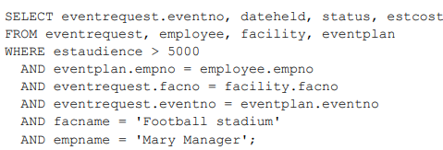

2)  Identify errors in the following Oracle SQL statement and label errors with error type (syntax, redundancy, or semantic). To simplify your work, the statement has only one type of error. Rewrite the statement to remove the error.

SELECT DISTINCT eventrequest.eventno, dateheld, status, estcost

FROM eventrequest, eventplan

WHERE estaudience > 4000

AND eventplan.eventno = eventrequest.eventno

GROUP BY eventrequest.eventno, dateheld, status, estcost;

A) ***Error :***  Redundancy error (Group By clause not needed)

***Correct Syntax :***

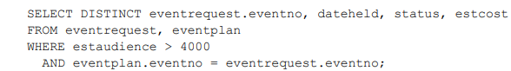

3) Identify errors in the following Oracle SQL statement and label errors with error type (syntax, redundancy, or semantic). To simplify your work, the statement has only one type of error. Rewrite the statement to remove the error.

SELECT DISTINCT eventrequest.eventno, dateheld, status, estcost

FROM eventrequest, employee, facility, eventplan

WHERE estaudience > 5000

AND eventplan.empno = employee.empno

AND eventrequest.facno = facility.facno

AND eventplan.eventno = eventrequest.eventno

AND facname = 'Football stadium';

A) ***Error :***  Redundancy error (Extra table (employee))

***Correct Syntax :***

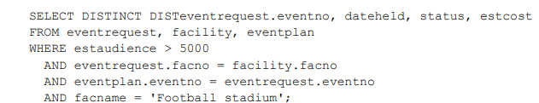

4)  Identify errors in the following Oracle SQL statement and label errors with error type (syntax, redundancy, or semantic). To simplify your work, the statement has only one type of error. Rewrite the statement to remove the error.

SELECT DISTINCT eventno, dateheld, status, estcost

FROM eventrequest, employee, eventplan

WHERE estaudience BETWEN 5000 AND 10000

AND eventplan.empno = employee.empno

AND eventrequest.eventno = eventplan.eventno

AND empname = 'Mary Manager';

A) ***Error :*** misspelled keyword (BETWEEN) and unqualified name (eventno).

***Correct Syntax :***

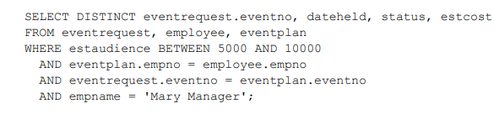

5)  Identify areas in which the SQL statement has poor coding practices and rewrite the statement to improve the coding practices. You do not need to search for errors.

SELECT eventplan.planno, lineno, resname,

numberfld, timestart, timeend

FROM eventrequest, facility, eventplan,

eventplanline, resourcetbl

WHERE estaudience = '10000'

AND eventplan.planno =

eventplanline.planno AND eventrequest.facno

= facility.facno

AND facname =

'Basketball arena' AND

eventplanline.resno = resourcetbl.resno

AND eventrequest.eventno = eventplan.eventno

A) ***Error :*** incompatible constant in WHERE condition : estaudience = ‘10000’

***Correct Syntax :***

